Project 2 Documentation

UML Diagram

The UML diagram for this project is the same as the UML for the last project, except instead of calculateArea(), and calculateVolume(), there are paint and draw methods for each shape

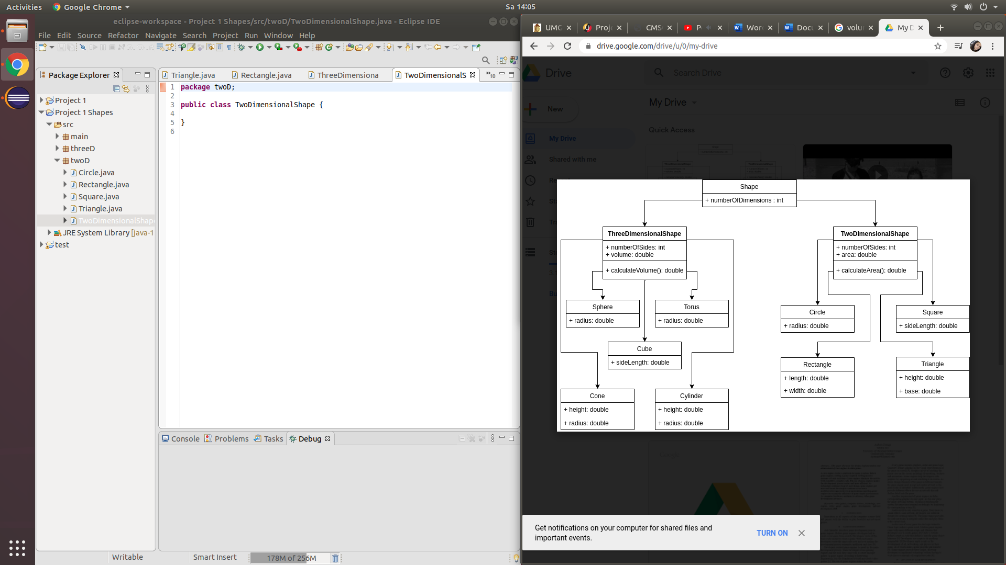

# User Guide

The main program is in the Menu class of the main package. To use the application, use the combo box to select which shape you would like. Once you click on your selection, enter the appropriate dimensions into the textbox(es) provided. Next, click on the generate shape button to see your shape! Press the refresh button to start again. Resizing of the window may be required depending on the size of the shape.

Testing Plan

My plan for testing involves 4 major steps

1. Make sure the program compiles
2. Test each option with correct input to make sure the option produces the appropriate output
   1. Circle:

Input: 50 Expected: small circle displayed on screen, Output: small circle displayed on screen

* 1. Rectangle:

Input: 50, 45 Expected: small rectangle displayed on screen Output: small rectangle displayed on screen

* 1. Square

Input: 50 Expected: small square displayed on screen Output: small square displayed on screen

* 1. Sphere

Input: 100 Expected: small sphere displayed on screen, Output: small sphere displayed on screen

* 1. Cube

Input: 100 Expected: small cube displayed on screen, Output: small cube displayed on screen.

* 1. Cone

Input: 100, 200 Expected: small cone displayed on screen Output: small cone displayed on screen

1. Incorrect parameters
   1. Empty boxes

Expected: Error window pop up, Output: Error window pop up

* 1. Non integer

Expected: Error window pop up, Output: Error window pop up

1. Not hitting refresh button between shapes

Expected: Error window pop up, Output: Error window pop up

Screen Shots in order of Testing Plan

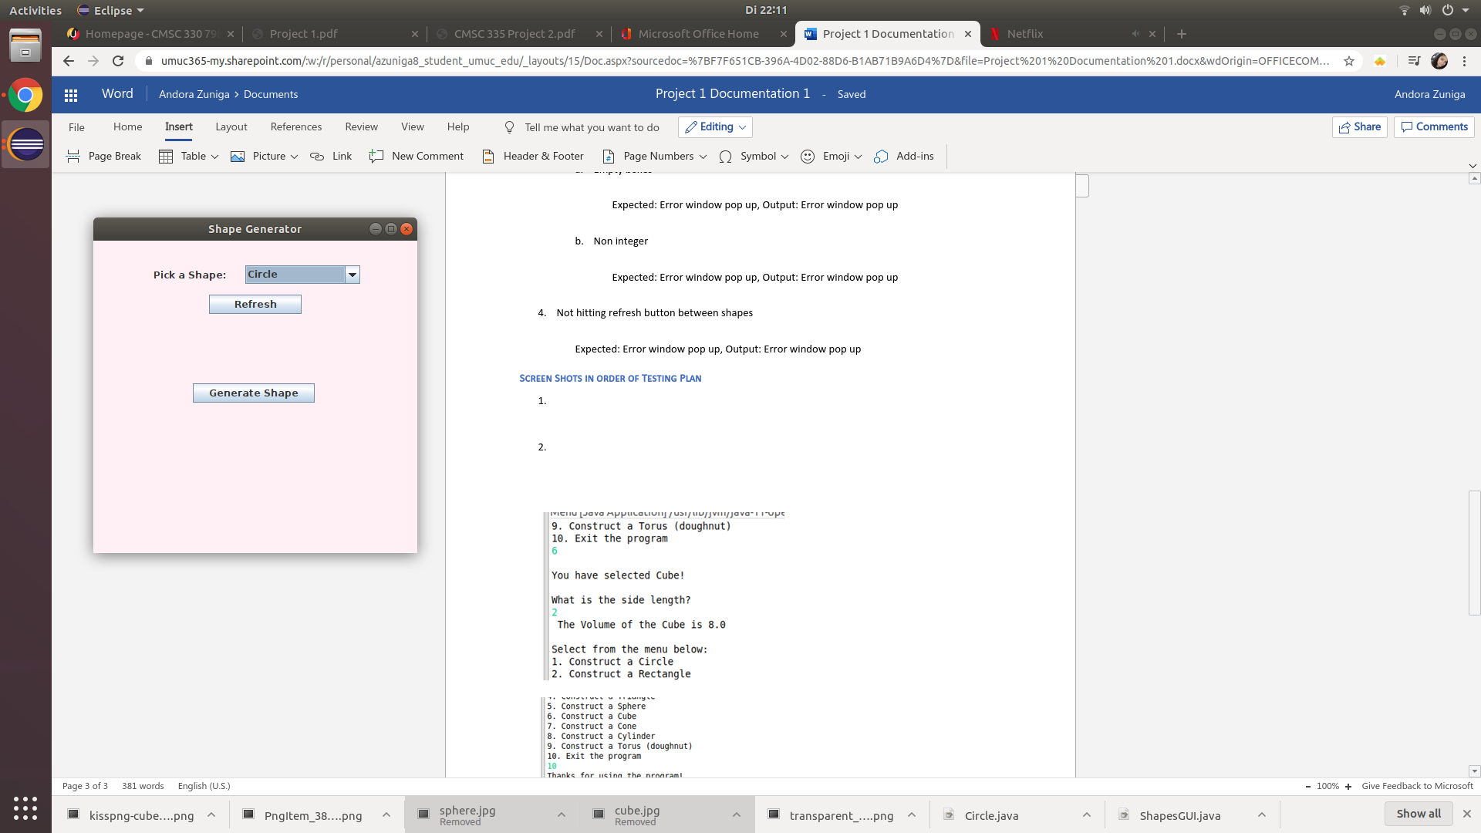

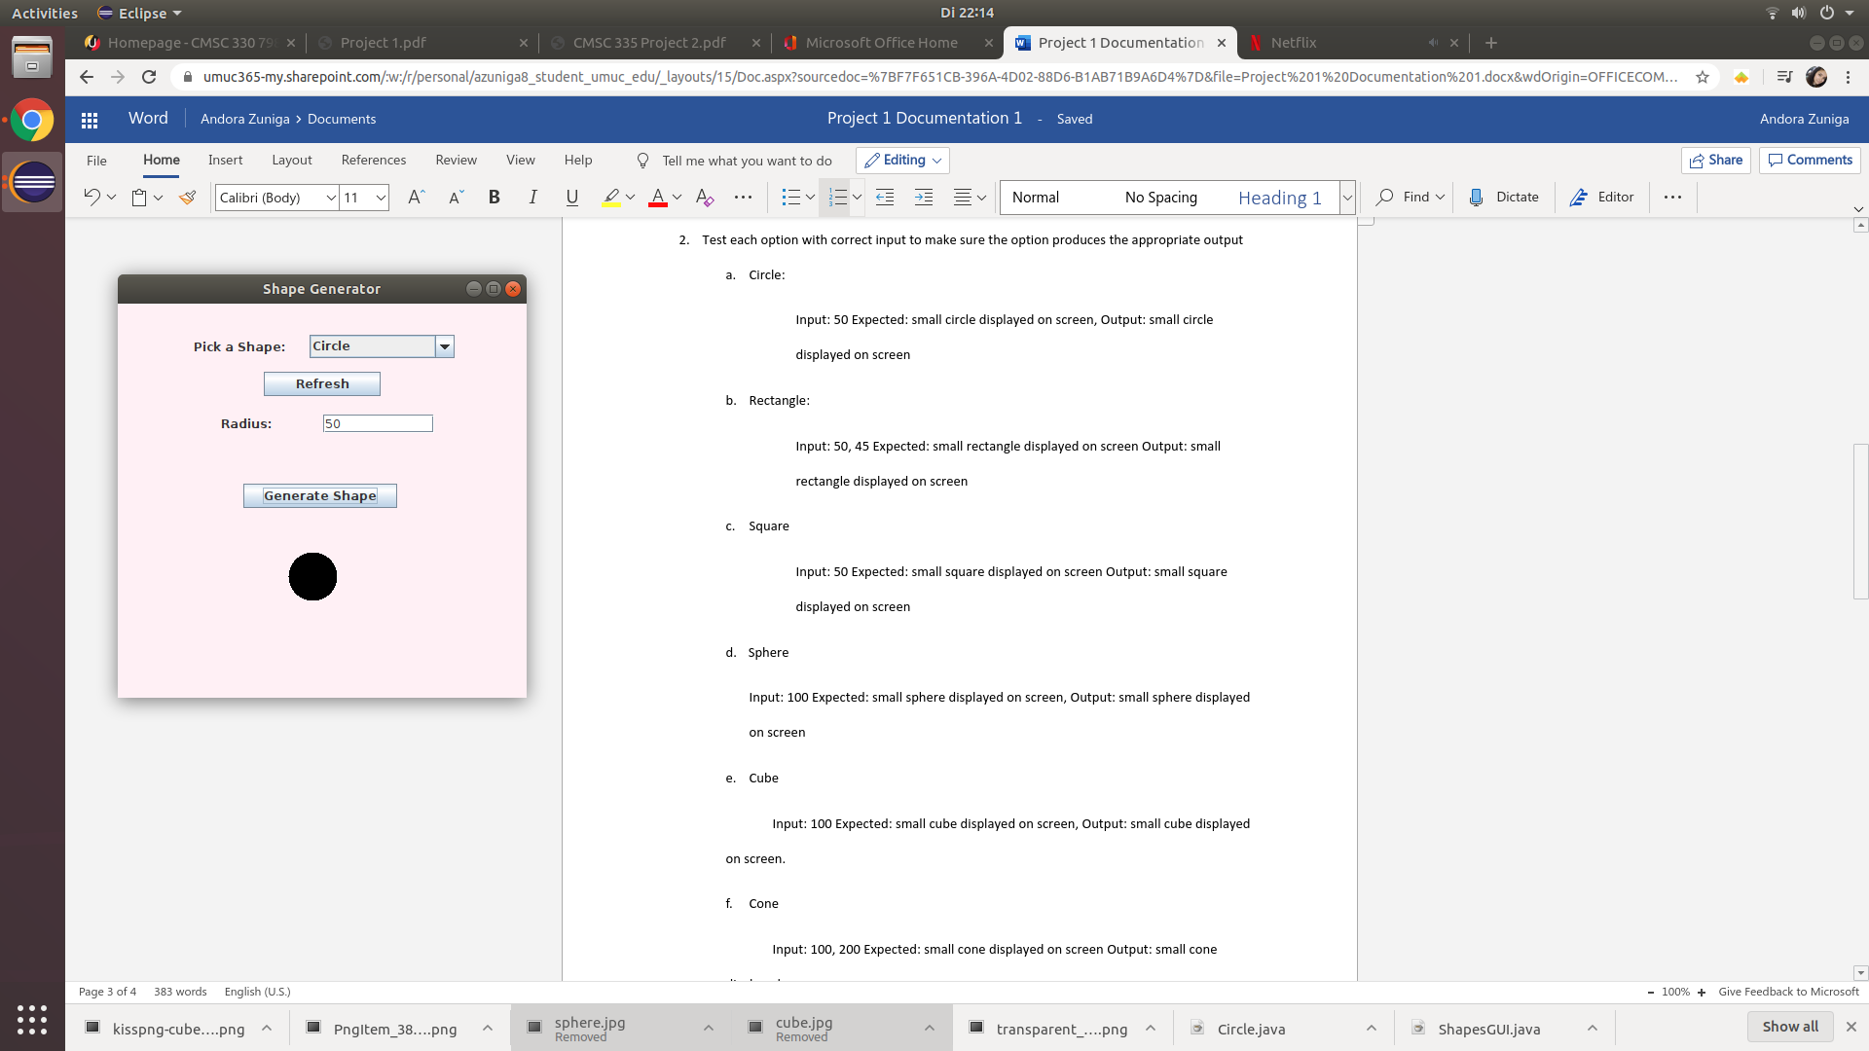

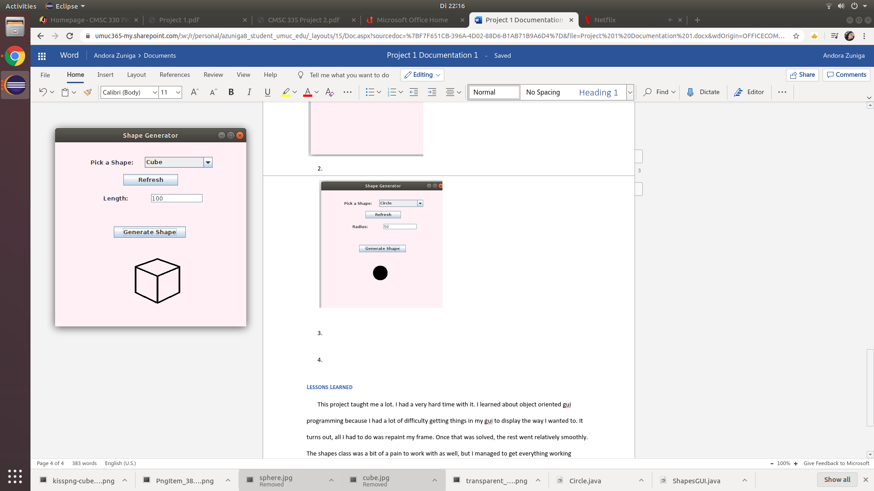

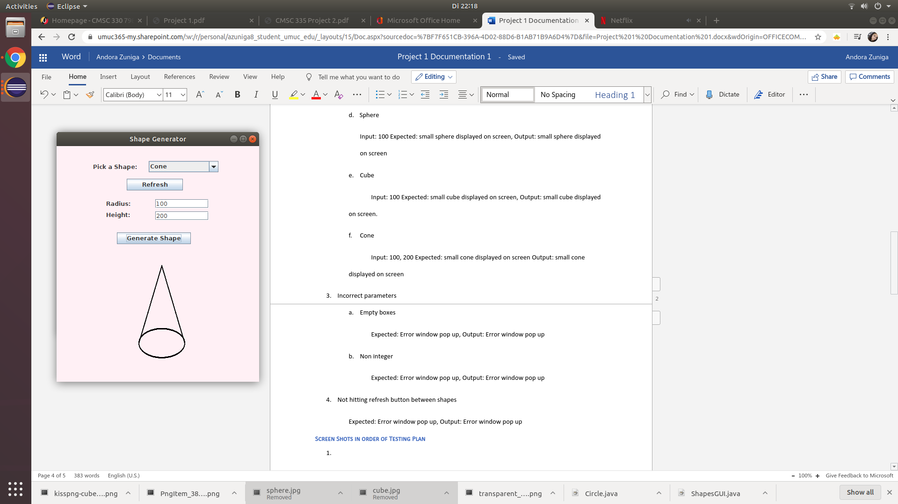

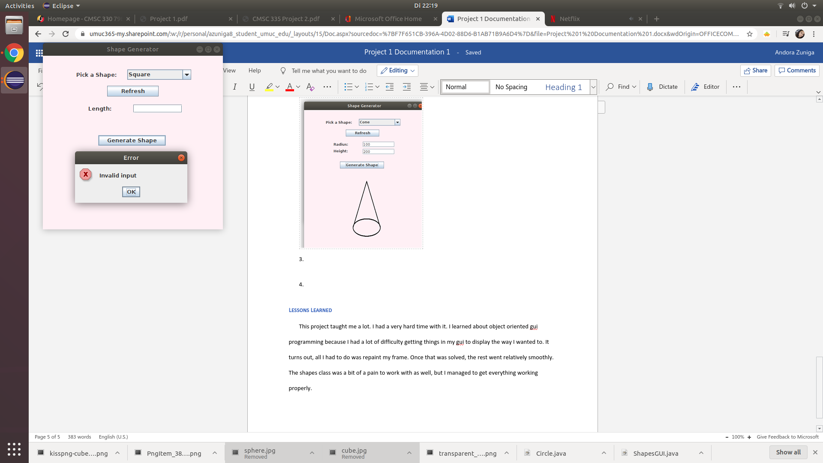

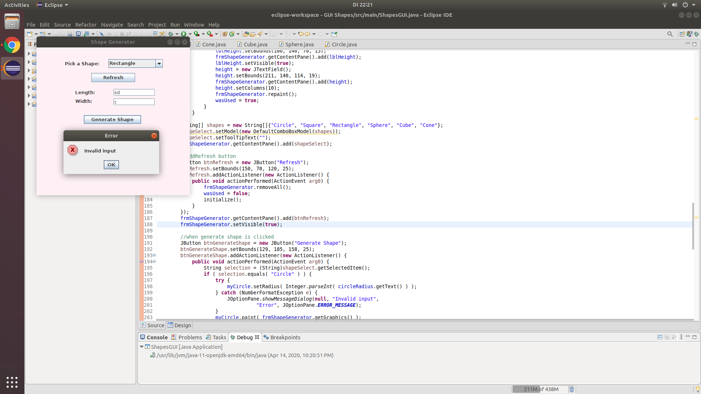

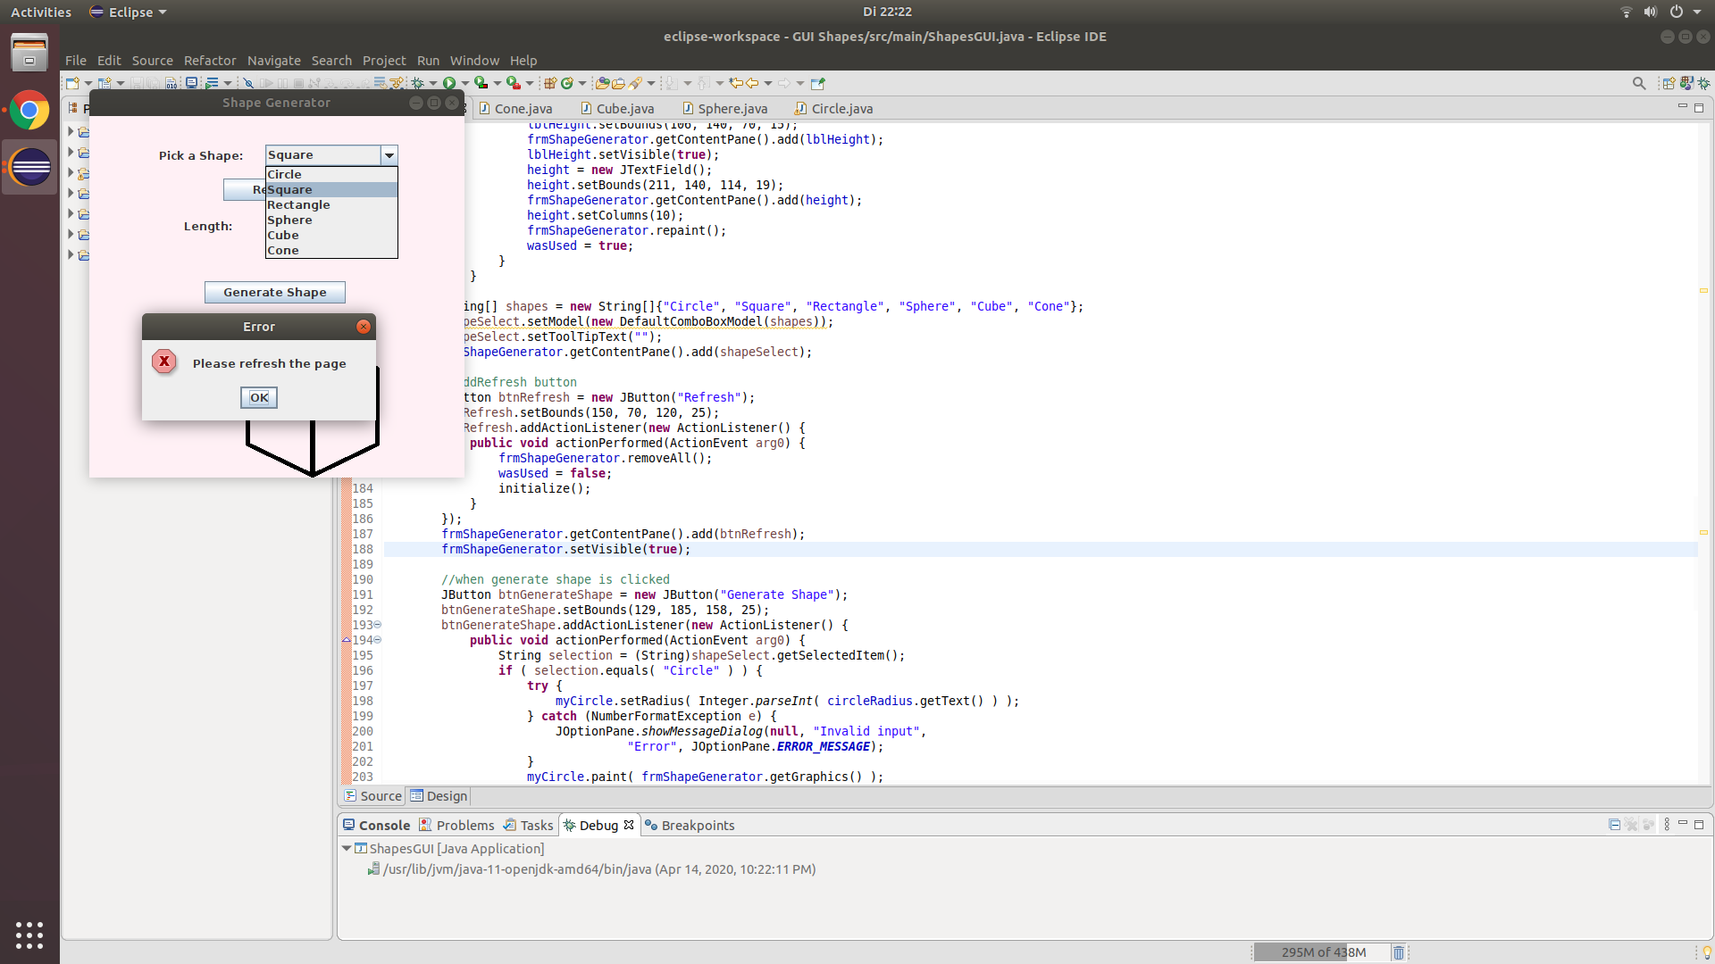

Lessons Learned

This project taught me a lot. I had a very hard time with it. I learned about object oriented gui programming because I had a lot of difficulty getting things in my gui to display the way I wanted to. It turns out, all I had to do was repaint my frame. Once that was solved, the rest went relatively smoothly. The shapes class was a bit of a pain to work with as well, but I managed to get everything working properly.